[1]

Preparation and Characterization of Chitosan Coated Magnetic Nanoparticles

1Qudsia Asad, 2Dr Arshad Javed, Department of Physics, University of Engineering and Technology, Taxila, Pakistan

***Abstract----***Magnetic nano-particles (MNPs) were prepared by using the co-precipitation method. In this method an aqueous solutions of ferric chloride hexahydrate (FeCl3.6H2O) and ferrous chloride tetrahydrate (FeCl2.4H2O) were added with a base under an inert atmosphere, followed by the modification of the surface of (MNPs) with chitosan. The characterization of the prepared magnetic nanoparticles was performed by X-ray diffraction (XRD), SEM (scanning electron microscopy) and Fourier transform infrared spectroscopy (FTIR) analyses. The prepared MNPs have many potential applications in biomedicine including targeted drug delivery, magnetic resonance imaging (MRI), and magnetic hyperthermia etc.

***Keywords--***Magnetic nano-particles, hyperthermia, Fourier transform infrared spectroscopy magnetic resonance imaging.

1. Introduction:

Nanotechnology is widely used throughout the pharmaceutical industry, chemical, medicine, electronics, robotics, and tissue engineering . It is playing a vital role in rapidly growing field of diagnosis and therapy of medicine[2]. The development of technology occurs at the atomic, molecular or macromolecular properties [1]. Nanoparticles (NPs) are defined as a small object that behaves as a whole unit in term of its transport and properties.[1].These are particulate dispersions or solid particles with a size in the range  
of 1–1000 nm.[3]. In order to get maximum performance of the nanoparticles, they should have uniform size and there should not be much variation in temperature because the magnetic moment varies with temperature due to the alignment of spins of free electrons [4].

Magnetic nanoparticles have a magnetic response and can be manipulated with an external magnetic-field gradient. Magnetic nanoparticles are composed of magnetic materials such as iron, nickel, cobalt strontium, lantanium ,zinc ferrites and their oxides.[2, 5].

Magnetic nanoparticles have unique macroscopic physical, chemical, thermal, and mechanical properties having super paramagnetic nature which offer a great potential in several biomedical applications, such as cell separation ,cell labeling, drug delivery, tissue repair, hyperthermia, magnetofection, detoxification of biological fluids, magnetic resonance imaging, targeting and manipulating biomoluecules, targeting drug and gene delivery, therapeutic agents in cancer treatment

[6]. For these applications of magnetic nanoparticles should have high magnetization values and particle size smaller than 100 nm.[7, 8]

The application of magnetic nanoparticles is not restricted to only material science but has expanded its tentacles in almost all areas of science such as agriculture, biomedical, and engineering [9-11]. In industry magnetic nanoparticles are commonly used as synthetic pigments in ceramics, paints, and porcelain. Magnetic encapsulates may find very important uses in many areas of life and also in various branches of industry. Magnetite have been applied as catalysts for a number of important reactions, such as the preparation of NH3, the desulfurization of natural gas, and the high-temperature water-gas shift reaction. Biomedical applications of magnetic nanoparticles can be classified according to their application inside or outside the body (*in vivo, in vitro*) [6]. In vitro applications included the activities that are performed in laboratory environment and outside of living organisms. The major ones of these applications are the magnetic detection and separation of cells, proteins, DNA and so forth by use of superparamagnetic iron oxides nanoparticles. On the other hand, *in vivo* applications, it could be further used in therapeutic (hyperthermia and drug-targeting) and diagnostic applications (nuclear magnetic resonance imaging [NMR], MRI etc.[6, 12].

Magnetite is the one of iron oxides known as an oldest magnetic material and also called black iron oxide, magnetic iron ore, and loadstone[12]. Beside lot of magnetic nanopaticles Magnetite, Fe3O4 is the magnetic material most commonly used and significant useful material in the field of medicine due to its many intrusting properties e.g. high chemical stability, low toxicity, and its magnetic saturation for being manipulated with an external field, biocompatibility and the heating ability in presence of an external field[5]. Magnetic nanoparticles are used to coat several surfactants to anti – aggregation which was caused by magnetic dipole – dipole attractions between particles[13].

In the recent past, many methods for synthesis of magnetite nanoparticles have been developed like co-precipitation, micro -emulsion, sol-gel, sputtering, thermal decomposition, solvothermal, sonochemical, microwave assisted, chemical vapor deposition, combustion synthesis, heterogeneous polymerization methods including suspension carbon arc, laser pyrolysis etc. With this variety of methods particles with

different size and structure such as spheres, rods, wires and tubes has been obtained [5, 14, 15].

|  |  |  |  |  |
| --- | --- | --- | --- | --- |
| **Synthetic method** | **Synthesis Reaction temp.(∘C)** | **Reaction time** | **Surface capping agents** | **Yield** |
| Coprecipitation | Very simple | 20–90 Minutes | During/after reaction | High |
| Microemulsion | Complicated | 20–50 Hours | During reaction | low |
| Thermal decomposition | Complicated | 100–320 Hours-days | During reaction | High |
| Hydrothermal | Simple | 200–250 Hours-days | During reaction | Medium |

Table 1.1

comparison of key properties of different synthetic method

However, the coprecipitation method is most significant and widely used method due to its simplicity, and mass production ability in industrial scale. It is an easy way to manipulate the size and morphology and raw materials are relatively inexpensive. [16] [12]. Although the synthesized particles by coprecipitation have higher crystallinity degree than other methods, the size of these particles is relatively larger with wide size distribution. In the preparation process, appropriately reducing lower reaction temperature and rapidly adding NaOH solution, the size of nanoparticles can be reduced [17].

In almost all uses, the synthesis method of the nanomaterials represents one of the most important challenges that will determine the shape, the size distribution, the particle size, the surface chemistry of the particles, and consequently their magnetic properties [13].

One of the most important aspects of the nanoparticles for its applications in biomedicine is the fictionalization of the nanoparticles for improving their biocompatibility with biological entities and provides chemical stability. The nanoparticles surfaces can be modified with a biocompatible or/and biodegradable polymeric coating. The polymer can be natural such as chitosan, collagen, folic acid synthetic as dextran , tetraethyl orthosilicate, N-(2-aminoethyl-3aminopropyl) trimethoxysilane, poly-lactic-co-glycolic acid ,polyethylene glycol, etc. This surface coating needs to have a functional groups like: carboxyl (-COOH), hydroxyl (-OH), amine (-NH2), etc, with the capability to bond with a biological molecules. Table 3 shows a summary of recent publications of the most used coating materials for magnetite nanoparticles [5].

Generally preparation of MNPs for biomedical applications involved three steps. Firstly, the preparation of magnetic nanoparticles of required size, secondly, the encapsulation of the nanoparticles using suitable polymer with active functional groups and lastly attachment of a desired functional group such as amine which is suitable to bind a targeted active component such as drug for medical applications.[4]

Table 1.2: Materials used in functionalization of magnetic nanoparticles.[5]

|  |  |  |
| --- | --- | --- |
| Material | Particle size (nm) | Application |
| Chitosan | 20-100 | Cell targeting, Tissue engineering, Drug delivery, hyperthermia |
| Polyethylene glycol (PET) | 10-50 | NMR imagines, Gen delivery |
| Polyvinyl Pyrrolidone (PVP) | 10-20 | Drug delivery |
| Polystyrene (PS) | 10-20 | NMR imagines DNA separation |
| Methyl polymethacrylate | 10-50 | NMR imagines, Entities separation |
| poly-lactic-coglycolic acid (PLGA) | 250 | Tissue engineering, Cell targeting |
| Silica | 0-300 | DNA separation, Drug delivery, Metal separation in waste |

Chitosan, a deacetylated derivative of chitin, is a polysaccharide with both a hydroxyl and an amine group in its structure. In addition, it is non-toxic, biocompatible, biodegradable, and anti-bacterial. It is insoluble in water, but becomes soluble and positively charged in acidic media [17]. It is a natural polymeric material widely used in biomedical applications as coating in magnetic nanoparticles for biomedical applications [7]. It is also used in many different types of applications (i.e. wastewater treatment, chromatographic support, electrochemical sensors and biosensors, bone substitutes , enzyme immobilization, drug-delivery systems)[18]. Chitosan can be produced by alkaline deacetylation of chitin, and chitin is the second most abundant natural polymer after cellulose, and therefore is a very cheap biopolymer[18] [19].

In this study, we prepared magnetic Fe3O4-chitosan nanoparticles by coprecipitation Fe(II) and Fe(III) in the presence of ammonium.[20] And then, the suspension cross-linking technique was used for the coating of nanoparticles with chitosan. The properties and structures of non-functionalized magnetic iron-oxide nanoparticles and chitosan-functionalized magnetic maghemite nanoparticles were characterized with Fourier transform infrared spectroscopy (FTIR), scanning electron microscopy (SEM) and XRD (X-Ray Diffractometer).

II. Materials and methods:

II-I PREPARATION OF MAGNETIC NANOPARTICLE FE3O4

II-I-I MATERIALS

Ferric chloride hexahydrate (FeCl3.6H2O), ferrous chloride

tetrahydrate (FeCl2.4H2O), and ammonium hydroxide, these were purchased from a German company Sigma Aldrich Co. All chemicals were used as such were bought without any kind of further refining or purification. Distilled water was used during this research wherever needed [2, 4, 5].

II-I-II Method

Magnetic nanoparticles of iron oxide were prepared by two-step process. In the first step, magnetite nanoparticles were produced by co-precipitation.The following technique stepwise is:

* 0.82 g of FeCl3.6H2O and then 0.6 g of FeCl2.4H2O were poured and then was dissolved in distilled water of 10 mL in a flask.
* This solution was stirred strongly at standard temperature of room (25°C) for 15 min and as a result we get a uniform dark orange solution.
* Ammonium hydroxide only 2.5 mL (28%) was poured dropwise under strong stirring to the uniform dark orange solution made in last step.
* In all this process, pH of the solution was maintained.
* Then half an hour later, this prepared mixture was kept for 45 min at 80 °C with energetic stirring.
* Then solution was then chilled to 25°C room temperature.
* Then by magnetic separation resulting products were separated from the system of the reaction and then to remove excess ammonia it was washed many times with double distilled water.
* And finally, the obtained nanoparticles of magnetic
* Fe3O4 were obtained after being dried in a vacuum oven at 25°C room temperature for one day (24h).[4,32]

|  |
| --- |
| **FeCl2.4H2O + 8NaOH + 2FeCl3.6H2O Fe3O4 + 20H2O + 8NaCl** |

II-IICoating of Magnetic nanoparticles (Fe3O4) with chitosan

II-II-I Materials

Magnetic nanoparticles (Fe3O4), Chitosan, NaTPP and Acetic acid were purchased from Deiging (Korea). All other chemicals were used without any further modification and were analytical grade. During this research wherever needed double distilled water was used.

II-II-II Method Step I: Make an aqueous solution of 0.45g of chitosan in 1.35ml of water and add 1.8ml of acetic acid in it.Step II: Dissolve 1.845g of Fe3O4 in 150ml of water.Step III: Mix these solutions of chitosan and magnetic nanoparticles.Step IV: Sonicate this mixture for 30 min.Step V:

Make a solution of 0.45g of NaTPP in 90ml of distrilledwater and add dropwise aqueous solution of NaTPP in the mixture of chitosan +distilled water +acetic acid and Fe3O4.Set magnetic stirrer on 3rmp at room temperature and apply the apparatus on magnetic stirring for 5 hours.StepVI: Centrifuge this solution for 30min at 6000rpm. Remove the water from the top of the solution with the help of a syringe.StepVII: Allow the sample to dry for several days. Liquid will be dried and we get chitosan coated magnetic nanoparticles.

1. RESULTS AND DISCUSSIONS

XRD (X-Ray Diffractometer)

The XRD analysis patterns for the bare Fe3O4 nanoparticles and nanoparticles coated with chitosan were showed in figure 1. All the peaks of Fe3O4 are compared with standard one with reference code # 00-002-1035. Six characteristic peaks for Fe3O4 marked by their indices (2 2 0), (3 1 1), (4 0 0), (4 2 2), (5 1 1) and (4 4 0) were observed in both samples which shows that the resultant nanoparticles were pure Fe3O4 with quasi-spherical structure. That is the reason for the unchangeable pace of Fe3O4 during coating process.[0012]

The particle sizes can also be quantitatively evaluated from the XRD data using the Debye Scherrer equation which gives a relationship between peak broadening in XRD and particle size.[014]

**d** = **(kλ / βcos θ)**  **…………………. (i)** where

* d is size of the particles,
* k is the Debye Scherrer constant (0.89),
* λ is the wavelength of X-ray (0.15406 nm)
* β is the full width at its half maximum (FWHM)
* θ is the Bragg’s angle.

$θ_{B}$**=Average angle**

We know that

**B= $\frac{1}{2}$ (2 $θ_{2}$-2 $θ_{1}$) …………………. (ii)**

**2 $θ_{B}$ = ($\frac{2θ_{1}+{2θ}_{2}}{2}$) …………………. (iii)**

Table 4.1 Naked Fe3O4 Grain Size (a) Calculation of FWHM (b) Calculation of average Grain size

|  |  |  |  |  |
| --- | --- | --- | --- | --- |
| Peak No | Angle(2 $θ)$ | 2 $θ_{1}$ | 2 $θ_{2}$ | (FWHM)  B=(${2θ}_{2}-{2θ}_{1})$/2 |
| 1 | 30.34 | 30.315 | 31.013 | 0.349 |
| 2 | 36.01 | 35.399 | 36.181 | 0.391 |
| 3 | 43.31 | 43.512 | 44.190 | 0.339 |
| 4 | 54.09 | 53.006 | 54.287 | 0.495 |
| 5 | 57.31 | 57.190 | 57.854 | 0.332 |
| 6 | 63.13 | 62.214 | 63.104 | 0.445 |

Table 4.2 SUBSTITUTE all values in equation (1) & (3)

|  |  |  |  |  |  |  |  |  |
| --- | --- | --- | --- | --- | --- | --- | --- | --- |
| Peak No | Plane | X-ray Wave Length  ($λ$) | FWHM  (B)  Rad | $$θ_{1}$$ | $$θ_{2}$$ | Average Angle $θ_{B}$ | Cos $θ_{B}$ | Grain Size  (t) |
| 1 | 220 | 1.54 $\dot{ A}$ | 6.066×10-3 | 15.1 | 15.5 | 15.331 | 0.96 | 23.7 |
| 2 | 311 | 1.54 $\dot{ A}$ | 5.911×10-3 | 17.6 | 18.0 | 17.894 | 0.95 | 25.0 |
| 3 | 400 | 1.54 $\dot{A}$ | 6.402×10-3 | 21.7 | 21.0 | 21.425 | 0.93 | 23.2 |
| 4 | 422 | 1.54 $\dot{ A}$ | 8.638×10-3 | 26.5 | 26.1 | 26.323 | 0.89 | 18.0 |
| 5 | 511 | 1.54 $\dot{A}$ | 6.025×10-3 | 28.5 | 28.9 | 28.761 | 0.87 | 27.0 |
| 6 | 440 | 1.54 $\dot{A}$ | 6.991×10-3 | 31.1 | 31.5 | 31.329 | 0.85 | 23.2 |

Average Grain size = 23nm

**1.tif**Fig 3.1 XRD analysis results of naked Fe3O4

Table 4.3 Chitosan Coated Fe3O4 Grain Size (a) Calculation of FWHM (b) Calculation of average particle size(a)

|  |  |  |  |  |
| --- | --- | --- | --- | --- |
| Peak No | Angle(2 $θ)$ | 2 $θ_{1}$ | 2 $θ_{2}$ | (FWHM)  B=(${2θ}_{2}-{2θ}_{1})$/2 |
| 1 | 30.27 | 30.102 | 30.701 | 0.299 |
| 2 | 35.74 | 35.404 | 36.108 | 0.352 |
| 3 | 43.62 | 43.438 | 44.376 | 0.469 |
| 4 | 57.38 | 57.112 | 57.912 | 0.400 |
| 5 | 62.53 | 62.323 | 63.171 | 0.424 |

Table 4.2 SUBSTITUTE all values in equation (1) & (3)

|  |  |  |  |  |  |  |  |  |
| --- | --- | --- | --- | --- | --- | --- | --- | --- |
| Peak No | Plane | X-ray Wave Length  ($λ$) | FWHM  (B)  Rad | $$θ_{1}$$ | $$θ_{2}$$ | Average Angle $θ_{B}$ | Cos $θ_{B}$ | Grain Size  (t) |
| 1 | 220 | 1.54 $\dot{A}$ | 6.021×10-3 | 15.051 | 15.350 | 15.200 | 0.9650 | 23.90 |
| 2 | 311 | 1.54 $\dot{ A}$ | 6.719×10-3 | 17.702 | 18.054 | 17.878 | 0.9517 | 24.71 |
| 3 | 400 | 1.54 $\dot{ A}$ | 8.141×10-3 | 21.810 | 22.188 | 21.999 | 0.9271 | 24.47 |
| 4 | 511 | 1.54 $\dot{ A}$ | 6.981×10-3 | 31.161 | 31.585 | 31.373 | 0.8537 | 23.62 |
| 5 | 440 | 1.54 $\dot{A}$ | 6.021×10-3 | 15.051 | 15.350 | 15.200 | 0.9650 | 23.90 |

Average particle size=24nm

C:\Users\pc\Desktop\qudsia\chitosan graph.tif

Figure 4.2 XRD pattern of (a) pure Fe3O4 (b) chitosan coated Fe3O4.

SEM (scanning electron microscopy)

This technique was used for the study of bare Fe3O4 and Fe3O4 coated with chitosan polymer which provides data aboutsize and shape of manufactured iron oxide nanoparticles. We operated the samples by using VEGA3 TESCAN machine at 20 Kv. The pure Fe3O4 and coated Fe3O4 with chitosan nanoparticles are shown in figure 4.3 and 4.4. For SEM, all the samples we analysed were in powdered form. The SEM analysis explain the morphology and surface structure of pure Fe3O4 and chitosan coated Fe3O4 nano-particles. In figure 4.4 we have wide spaces and rough surface because our samples were in powder form. The sample shows the quasi-spherical shape of chitosan coated magnetic nanoparticles[9]. In all the images an even distribution of the magnetite nanoparticles was observed. The pure Fe3O4 has smooth surface with very strong agglomeration[21] (some kind of cluster of different materials) but after coating of Fe3O4 nanoparticles with chitosan agglomeration reduced with higher concentration of chitosan [40].

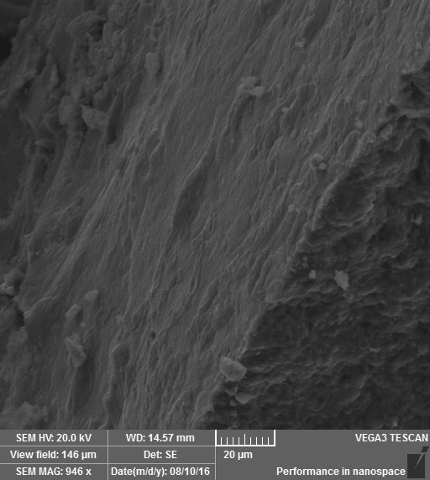.

Fig 4.3 SEM analysis of naked Fe3O4

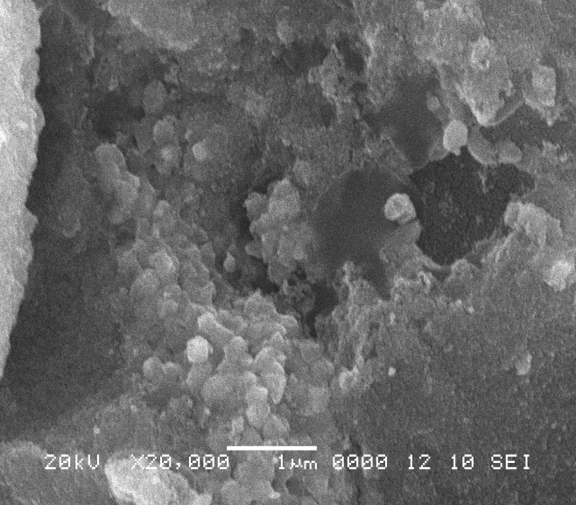

Fig 4.4 SEM analysis of Chitosan Coated Magnetic Nanoparticles

After surface modification in images we observe the little aggregation. The basic reasons of agglomeration in pure Fe3O4 nanoparticles have Vandar Walls force between the particles. After surface modification the chitosan particles envelops the original Fe3O4 and reduced the agglomeration*.*

Energy Dispersion X-ray Spectroscopy (EDX) Analysis

EDX analysis objective is to examine the presence of elements as was shown in Fig 4.5.as.Fe, O, Cl by weight % peaks were obtained on the surface of bare MNP respectively while Fe, O, C ,P and C l peaks were obtained with 51.2, 27.0,16.8,3.7 and 1.4 by weight.% respectively. The amount of C, which signify good stability and high storage of the chitosan layer with very good adsorption by the large surface area of paramagnetic Fe3O4. To verify the binding of chitosan complexes on the surface of Fe3O4 nanoparticles, EDX analysis were performed[22]. Figure 4.5 (a) and (b) shows the obtained peaks of each sample. Figure 4.5(a) shows the clear peaks of Fe, Cl and O. The table shows the weight % of bare and coated nanoparticles elements.

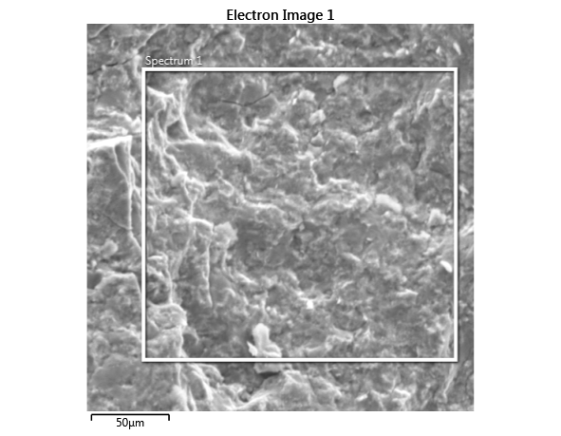

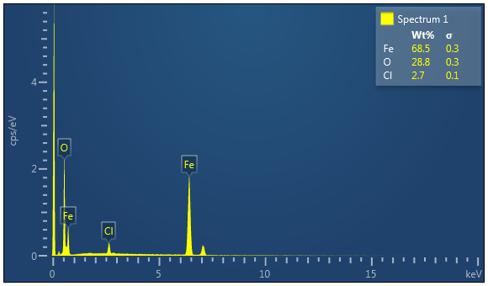Fig 4.5 EDX analysis results of naked Fe3O4

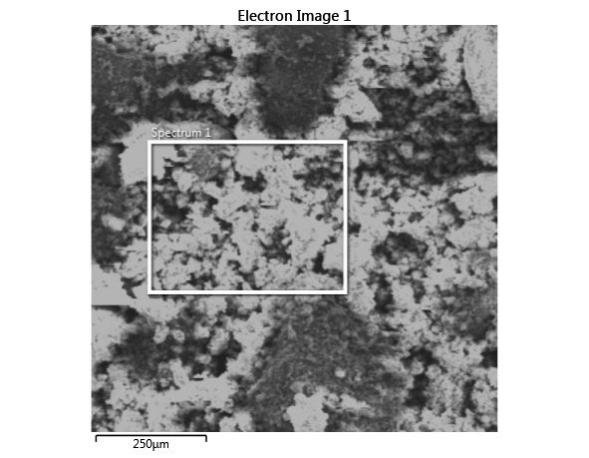

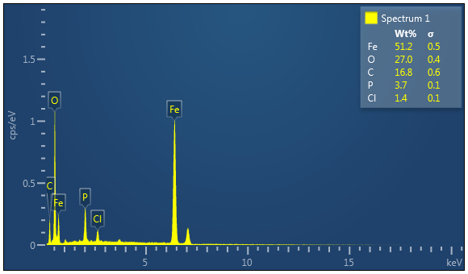

Fig 4.6 EDX analysis results of chitosan coated Fe3O4

## Fourier Transform Infrared Spectroscopy (FTIR)[23].

## FTIR analysis was applied to verify the presence of

Figure 4.8 FTIR results of chitosan coated Fe3O4

## different coatings on super paramagnetic iron oxide nanoparticles (SPIONs). Following figure 4.6 shows the characteristic peaks of the bared and chitosan coated SPIONs. For all the samples, a main band at 577.5 cm−1 is attributed to the vibration of Fe-O [[34](https://www.ncbi.nlm.nih.gov/pmc/articles/PMC4574187/#CR19)]. And for the FTIR spectrum of the naked SPIONs (Fig. [4.6 a](https://www.ncbi.nlm.nih.gov/pmc/articles/PMC4574187/figure/Fig1/)),[35]. The study of chemical bonds between the Fe3O4 nanoparticles and chitosan coated Fe3O4 investigated using FTIR. The samples were analyzed between the ranges of 4000 cm-1 to 7000 cm-1. In figure (a) the strong and board peak of Fe3O4 obtained at 698.23 cm-1 due to the extended shaking of Fe-O bond. The intensive and broadband peak obtained at 3115.04cm-1to 1622.13 cm-1 due to stretching vibration in O-H bond through hydrogen bond. We obtained the FTIR spectra of maghemite and chitosan coated maghemite with different consecration, as is shown in figure 4.5 a and b. Fe3O4/chitosan shows shift in peaks intensity as is shown in figure 4.6(b). Chitosan shows the peaks at 696.30cm-1 due to Fe-O bond respectively. The strong and board peak due to Fe-O bond increased with higher concentration of chitosan. The board and strong peaks obtained at 31136.12cm-1 and 1622.13cm-1 of chitosan respectively. The C-O-C ether stretch band at 11541.86 cm-1 and vibration band at 1218.81cm-1 appear in the spectrum of FTIR of nanoparticles after chitosan modification respectively. The CH and C-O-C and peaks are a very strong proof that chitosan-coated nanoparticles surface. Thus these observations above confirm the successful attachment of the chitosan onto the surface of Super Paramagnetic Iron Oxide Nanoparticles.



Figure 4.8 FTIR results of chitosan coated Fe3O4

1. Conclusions

Magnetic nanoparticles of iron oxide were prepared by two-step process. In the first step, magnetite nanoparticles were produced by co-precipitation of Fe2+ and Fe3+ salts solution with NaOH solution and in the second step, formed magnetite nanoparticles were coated with the polymer using emulsion polymerization. Resulting samples of nanoparticles were analyzed utilizing XRD, SEM and FTIR. It was found that prepared nanoparticles were generally quasi-spherical in shape and have particle size of about 23 nm and that they tend to form agglomerates. The coating process had no changing effect in the quasi-spherical structure of Fe3O4. The presence of the polymer in the nanoparticles blend was confirmed by means of FTIR spectroscopy[12]. . The nanoparticles have a potential for use in assisted drug delivery systems, cell/enzyme immobilization and many other industrial processes.[10]

1. References

[1] M. Mahdavi et al., "Synthesis, surface modification and characterisation of biocompatible magnetic iron oxide nanoparticles for biomedical applications," Molecules, vol. 18, no. 7, pp. 7533-7548, 2013.

[2] T. Indira and P. Lakshmi, "Magnetic nanoparticles—a review," Int. J. Pharm. Sci. Nanotechnol, vol. 3, no. 3, pp. 1035-1042, 2010.

[3] L.-M. Zhao et al., "Preparation and application of chitosan nanoparticles and nanofibers," Brazilian Journal of Chemical Engineering, vol. 28, no. 3, pp. 353-362, 2011.

[4] B. Issa, I. M. Obaidat, B. A. Albiss, and Y. Haik, "Magnetic nanoparticles: surface effects and properties related to biomedicine applications," International journal of molecular sciences, vol. 14, no. 11, pp. 21266-21305, 2013.

[5] P. E. G. Casillas, C. A. M. Pérez, and C. A. R. Gonzalez, Infrared spectroscopy of functionalized magnetic nanoparticles. INTECH Open Access Publisher, 2012.

[6] A. Akbarzadeh, M. Samiei, and S. Davaran, "Magnetic nanoparticles: preparation, physical properties, and applications in biomedicine," Nanoscale research letters, vol. 7, no. 1, p. 144, 2012.

[7] Y. Osuna et al., "Chitosan-coated magnetic nanoparticles with low chitosan content prepared in one-step," Journal of Nanomaterials, vol. 2012, p. 103, 2012.

[8] P. Businova et al., "Polymer coated iron oxide magnetic nanoparticles: preparation and characterization," Nanocon, vol. 9, pp. 21-23, 2011.

[9] A. Roca et al., "Progress in the preparation of magnetic nanoparticles for applications in biomedicine," Journal of Physics D: Applied Physics, vol. 42, no. 22, p. 224002, 2009.

[10] M. Faraji, Y. Yamini, and M. Rezaee, "Magnetic nanoparticles: synthesis, stabilization, functionalization, characterization, and applications," Journal of the Iranian Chemical Society, vol. 7, no. 1, pp. 1-37, 2010.

[11] C. M. Niemeyer, "Nanoparticles, proteins, and nucleic acids: biotechnology meets materials science," Angewandte Chemie International Edition, vol. 40, no. 22, pp. 4128-4158, 2001.

[12] M. R. Ghazanfari, M. Kashefi, S. F. Shams, and M. R. Jaafari, "Perspective of Fe3O4 Nanoparticles Role in Biomedical Applications," Biochemistry research international, vol. 2016, 2016.

[13] H.-M. Liu and J.-K. Hsiao, Magnetic Nanoparticles: Its Effect on Cellular Behaviour and Potential Applications. INTECH Open Access Publisher, 2012.

[14] H. A. Eivari, A. Rahadr, and H. Arabi, "Preparation of superparamagnetic iron oxide nanoparticles and investigation their magnetic properties," Int. J. Sci. Eng. Inves, vol. 1, no. 3, pp. 70-72, 2012.

[15] L. Guo, G. Liu, R.-Y. Hong, and H.-Z. Li, "Preparation and characterization of chitosan poly (acrylic acid) magnetic microspheres," Marine drugs, vol. 8, no. 7, pp. 2212-2222, 2010.

[16] T. Ozdemir, D. Sandal, M. Culha, A. Sanyal, N. Z. Atay, and S. Bucak, "Assembly of magnetic nanoparticles into higher structures on patterned magnetic beads under the influence of magnetic field," Nanotechnology, vol. 21, no. 12, p. 125603, 2010.

[17] P. P. I. K. MAGNETNIH, P. NANODELCEV, and E. S. HITOZANOM, "SYNTHESIS COMPARISON AND CHARACTERIZATION OF CHITOSAN-COATED MAGNETIC NANOPARTICLES PREPARED WITH DIFFERENT METHODS," Materiali in tehnologije, vol. 48, no. 5, pp. 689-692, 2014.

[18] E. Alzahrani, "Fabrication and characterisation of chitosan-magnetic nanoparticles and its application for protein extraction," International Journal of Advanced Scientific and Technical Research, vol. 4, no. 4, pp. 755-766, 2014.

[19] D. T. K. Dung, T. H. Hai, B. D. Long, and P. N. Truc, "Preparation and characterization of magnetic nanoparticles with chitosan coating," in Journal of Physics: Conference Series, 2009, vol. 187, no. 1, p. 012036: IOP Publishing.

[20] M. Shen et al., "The synthesis and characterization of monodispersed chitosan-coated Fe 3 O 4 nanoparticles via a facile one-step solvothermal process for adsorption of bovine serum albumin," Nanoscale research letters, vol. 9, no. 1, p. 296, 2014.

[21] A. Sharafi and M. Seyedsadjadi, "Surface-Modified Superparamagnetic Nanoparticles Fe 3 O 4@ PEG for Drug Delivery," magnetic resonance imaging (MRI), vol. 4, p. 6.

[22] M. ŞERB et al., "Fe3O4 NANOPARTICLES COATED WITH Zn (II)-CARBOXYLATO COMPLEXES," magnetic resonance imaging (MRI), vol. 5, p. 15.

[23] A. Avram, A. Radoi, V. Schiopu, M. Avram, and H. Gavrila, "Synthesis and characterization of γ-Fe2O3 nanoparticles for applications in magnetic hyperthermia," Synthesis, vol. 10, no. P151, p. 1, 2011.

1. .